

Laxman Dutt Degala | CS590BD | July 8, 2014

Lab 4 Assignment

**Tasks:**

1. Create test data for the “punch” gesture.
2. Have used the existing (provided) train data to test my gesture data.
3. Do the ‘*machine learning*’ part from the android mobile, by interacting with cloudera.
4. Problems faced & Things learnt
5. Enhancements – how it’s helpful for our project
6. Create test data for the punch gesture.

Please find the raw data (attached in github – *punch_laxman*) for the ‘punch’ gesture. This has been converted to .seq format with the help of the web service provided.

1. For simplicity purpose, I have generated test data just for punch.

I have used the train data. That’s provided by TA. This is check the difference when there is change in test data.

Also, I have used the left2right and right2left gestures provided in the tutorial. Please find the attached .seq file for the test data in github.

1. Main idea of this lab is to take the raw data that comes out from different gestures. Once the gestures are given, user will save the data by clicking on a button. ONCLICK, the data is converted to .seq file and then machine learning part will be done by comparing the dataset with the train data. The results are sent back to the mobile device for the user to check his/her performance.

In the background, data is moved to HBASE and machine learning part is done and the results are sent back.

In order to do this, I have made small changes to the lab 3 assignments, which enables me to use the existing web services and which in turn helps me do the machine learning part. Please look at Github for the code.

Snapshots:

Raw data is successfully converting into the chunks (.seq) as required for the web service.

I have tried creating 3 buttons;

1. To convert test2seq
2. Machine learning part – TEST and TRAIN data are combined and compared.
3. Use the existing data provided by TA to compare the results.

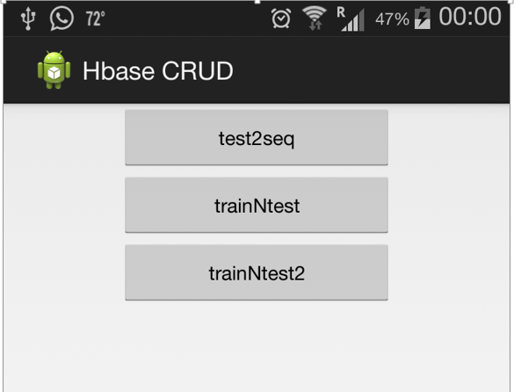

Unfortunately, the server is down all the time, I have tried using both the servers.

Below is the snapshot when I tried creating a .seq file again for snapshot purpose.

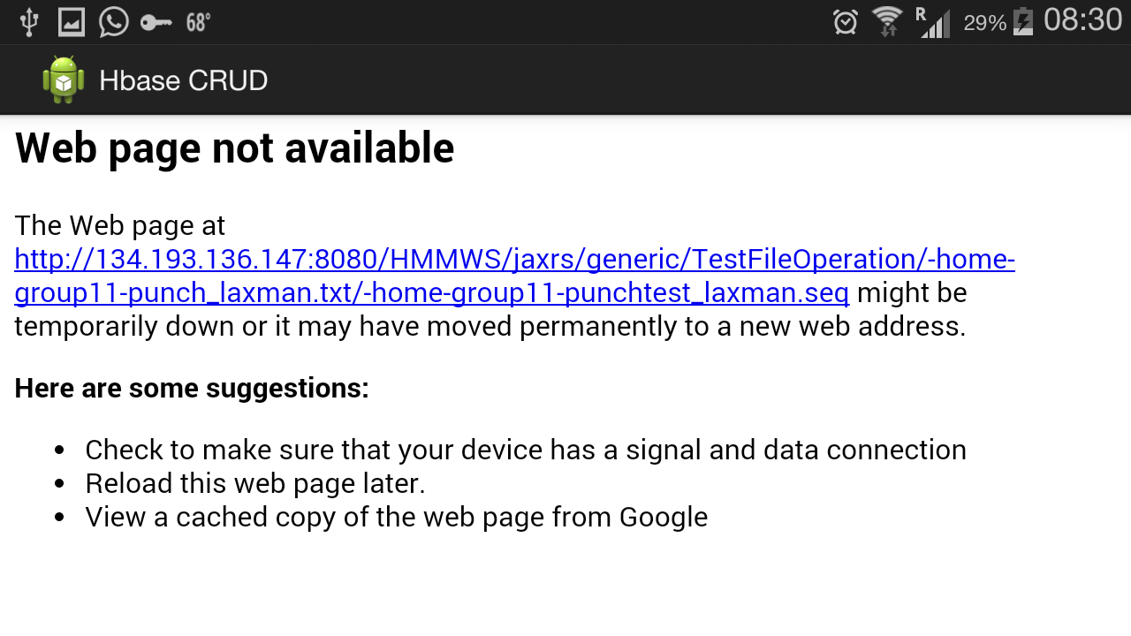

Have tried to hit the URL provided in the tutorial, to make sure there is no issue with my code. It didn’t work, Service is down.

Have tried again when the service is up. Could get the results as expected. Please find below the screenshot.

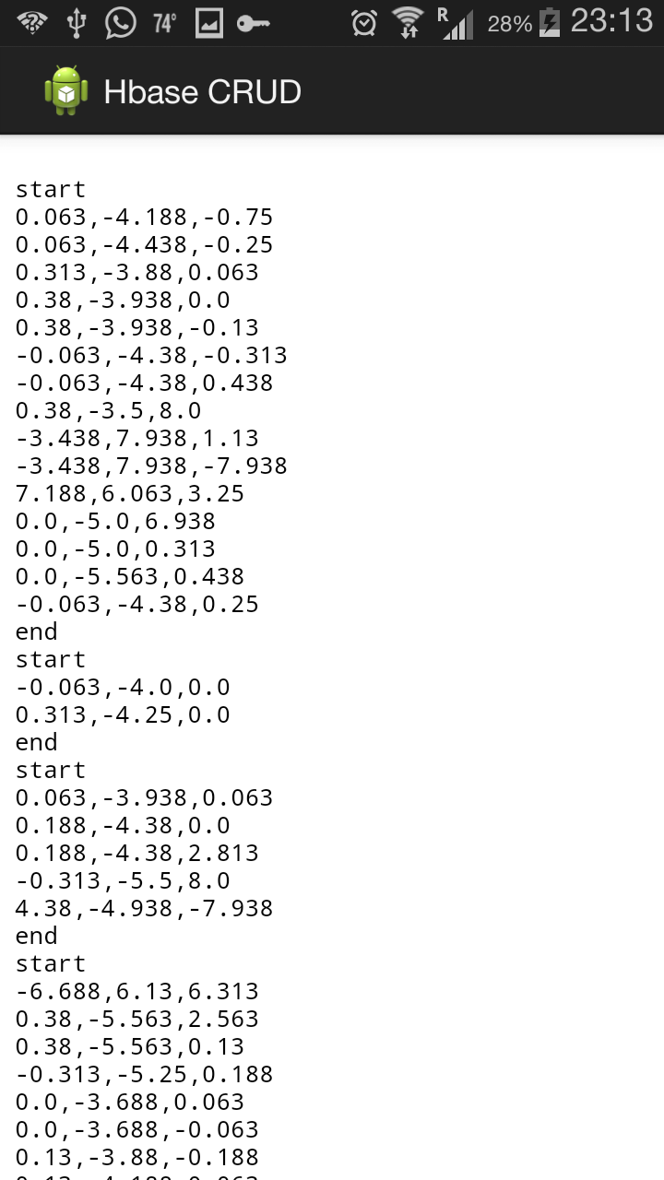

**Problems faced:**

1. Service is fluctuating. Either Glassfish is down or the complete service is down for almost entire day.
2. Have contacted Shen to rectify the problem. He restarted the service but it was down again.
3. Have tried using my own web service by making a copy and using a different web service. It didn’t work too.

**Enhancements – How it helps our project:**

Have understood how the raw data is converted to useful information.

Will use my cloudera image to work for the project instead of the service provided in the class, as it’s crashing frequently due to load.

I will come up with few more results on the test and train by working on my own data used for our project ‘*Emotion Sensor*’.